Project: Motswana Auto Electrical – Enterprise Network Design
Prepared By: Musa Prince Sithoza
Student Number: 45500207
Location: Taung
Module: CMPG 325
Date: 02/10/2026

1.Introduction
This report documents the implementation and testing phase of the Motswana Auto Electrical network. Following the approved design from Milestone 1, the network was built in Cisco Packet Tracer and configured to provide full connectivity between the Admin, Workshop, and Sales departments. This report covers the features implemented, the testing performed, the challenges encountered, and the final results.

2.Implemented Features
The following features were successfully implemented in the Packet Tracer simulation:
- Physical Topology: A Hub-and-Spoke design with a Main Router at the centre connected to three department routers (Admin, Workshop, Sales) via Serial DCE WAN links.
- VLANs: Four VLANs were created to segment the network:
  - VLAN 10 – Admin
  - VLAN 20 – Workshop
  - VLAN 30 – Sales
  - VLAN 40 – Servers
- Inter-VLAN Routing: Configured on the Admin Router using sub-interfaces (GigabitEthernet0/0.10 and GigabitEthernet0/0.40) so that VLAN 10 and VLAN 40 can communicate.
- OSPF Routing: Enabled on all four routers so that each department can dynamically learn routes to the other departments.
- DHCP: Configured on the Admin Router to automatically assign IP addresses to all PCs and devices in every department.
- Trunk Ports: Configured between each switch and its router so that multiple VLANs can travel over a single physical link.
- WAN Serial Links: Configured between the Main Router and each department router with the correct IP addresses and clock rates.
- Server: Placed in the Admin department and configured with a static IP address.
- IP Phones: Connected in each department and powered on.

3.Testing Evidence
The network was tested using ICMP ping from the Admin PC to confirm full connectivity.
3.1 Admin PC → All Three Routers
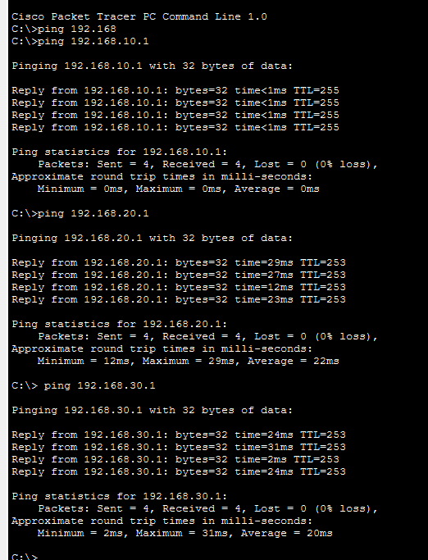Result: The Admin PC successfully pinged all three routers:
- Admin Router (192.168.10.1) → 0% packet loss (4/4 replies)
- Workshop Router (192.168.20.1) → 0% packet loss (4/4 replies)
- Sales Router (192.168.30.1) → 0% packet loss (4/4 replies)
This proves that routing between all departments is working correctly.
3.2 Admin PC → Workshop PC and Sales PC (End-to-End)
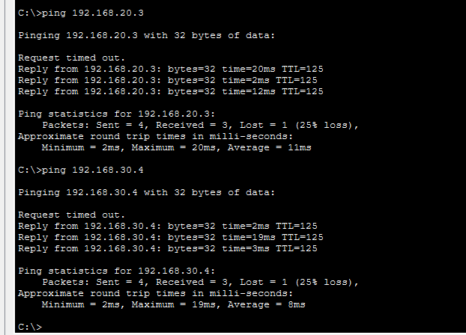

Result: The Admin PC successfully pinged PCs in the other departments:
- Workshop PC (192.168.20.3) → 3/4 replies (first packet lost during ARP resolution)
- Sales PC (192.168.30.4) → 3/4 replies (first packet lost during ARP resolution)
This proves full end-to-end connectivity between departments. The initial packet loss is expected because the PC must first resolve the destination MAC address using ARP before ICMP packets can be delivered. This is normal network behaviour.

3.3 Main Router Routing Table
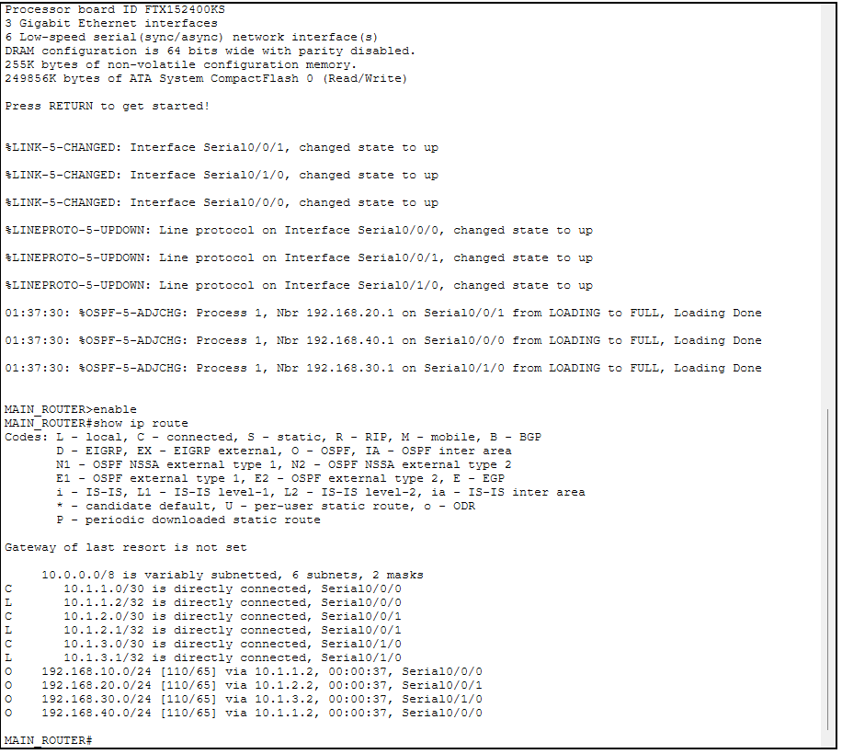

Result: The Main Router knows all four department networks via OSPF (O 192.168.10.0/24, O 192.168.20.0/24, O 192.168.30.0/24, O 192.168.40.0/24). This proves dynamic routing is working.
3.4 OSPF Neighbor Status
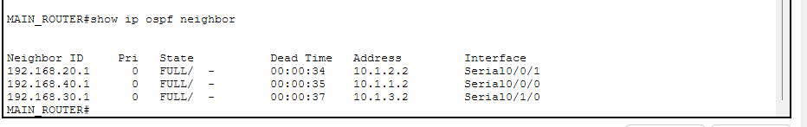
Result: All three OSPF neighbours are in FULL state (Admin, Workshop, Sales). This confirms the routing protocol is operational on every WAN link.

4. Challenges Encountered and Resolved
During implementation, several challenges were encountered and resolved:
Challenge | Solution
An extra serial cable accidentally connected Admin and Sales routers, creating a routing loop. | Removed the extra cable to restore the Hub-and-Spoke topology.
DHCP failed for Workshop and Sales departments. | Configured ip helper-address on the Workshop and Sales routers pointing to the DHCP server.
The Admin Switch port connected to the router was not in trunk mode. | Changed port Fa0/9 to switchport mode trunk so VLAN 10 and VLAN 40 could reach the router.
A PC in the Admin department could not obtain a default gateway. | Re-created the DHCP pool on the Admin Router with the default-router 192.168.10.1 command.
The original 2911 router did not support Call Manager Express for IP Phones. | Focused on completing data connectivity, which was successfully achieved.

5. Conclusion
The Motswana Auto Electrical network has been fully implemented and tested. All three departments can communicate with each other successfully, DHCP is providing IP addresses automatically, and OSPF is dynamically sharing routes between all routers. The testing evidence confirms that the network is stable and ready for the final evaluation phase in Milestone 3.

6. GitHub Repository
All files for this milestone are available in the project repository:
Repository Link: ( https://github.com/Sithoza/NETWOKING )

